

**Lesson 1 – Implementation & Python Basics**

**Background:** For this introductory lesson, we will be installing the Anaconda - Python distribution as a foundation for developing and learning the core principles of an A.I. or Machine-Learning project. The first step is understanding the implementation process of Python on your computer, and using Jupyter Notebooks to test your code.

**Download Anaconda**

1. Open a web browser and go to the following link: <https://www.continuum.io/downloads>
2. Scroll down and select your current Operating System.
3. Select the newest Python version available for download. (i.e. 3.x over 2.x)

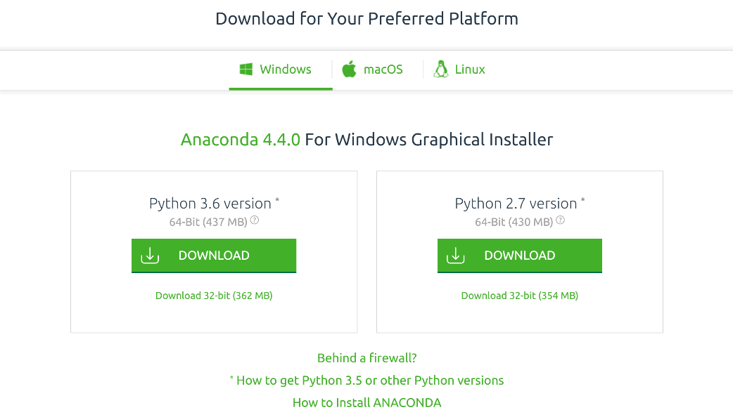

**Install Anaconda**

1. Run the install file once downloaded.
   1. Leave all installation settings as default!
   2. Ensure that Anaconda is selected as your default Python 3.x provider near the end of the installer steps, just before commencing installation.

**Launch Jupyter**

1. Open your start menu and search ‘Jupyter Notebook’
   1. If it does not show up – navigate to the Anaconda folder
   2. We recommend that you pin or create a shortcut
2. Launch Jupyter, give it a moment to launch a browser window from the console window that pops up initially
   1. You should see the directory structure of your computer now
3. Create a folder called ‘Workshops’ in a location of your choice